Thermal Model of a Li-ion Battery

Determining the heat transfer of a battery on its surroundings.

Jacob Turner

ENGR 421

5/16/2019

Introduction

Lithium-ion batteries are an indispensable technology that have come to power a significant amount of the productivity in the 21st century. One critical parameter important to the performance of lithium-ion batteries is the temperature gradient under a load ("Discharging at High and Low Temperatures" 2019). The thermal conditions of the environment and the temperature gradient of the battery cell have a large influence on the overall performance and energy storage of a Lithium-ion battery. Hence, it will be useful to understand the thermal affects of a battery on its environment while it is under a constant discharge. A battery that runs too cold will risk a drastic increase in internal resistance, which can decrease the overall capacity and length of runtime of the battery ("Discharging at High and Low Temperatures" 2019). Alternatively, running too hot can permanently shorten its lifetime, in addition, high temperatures can potentially damage other electronic components that are in proximity.

A python program was created using the FeniCS module and other libraries to create a thermal model of a 3D Lithium-ion battery cell under a constant discharge. The model will help to understand which parameters the largest effect on the temperature gradient within the battery cell have, as well as how these affect the performance. Gaining insight into this behavior could help one to create more thorough thermal battery management systems to help improve the efficiency of electric vehicles and other devices. Lastly, a sensitivity analysis will be performed on the current discharge, internal resistance of the battery, voltage variation, and volume to help in understanding how the uncertainty in these values affect the heat transfer with the surroundings of the battery cell.

Literature Review

Lithium-ion batteries have become immensely important over the last few decades with the introduction of various portable electronic devices from smart phones to electric vehicles. This has caused a surge of interest in the scientific community in the thermal behavior of the battery cells to optimize the energy storage and performance of these electronic devices. The performance of Li-ion battery systems is dependent on the thermal behavior and temperature gradient uniformity inside the cell [ Wang, Ma, and Zhang, 2017]. This has caused many researches to embark on creating models to help in thoroughly understanding this behavior. One paper title, “Finite Element Thermal Model and Simulation for a Cylindrical Li-ion Battery”, by Zhenpo Wang, Jun Ma, and Lei Zhang aimed at validating the thermal model they created using finite element analysis with empirical experimentation and verifying the accuracy of the simulation method. Overall, the results of this research were able to narrow the total error deviation from temperature in the simulation down to approximately 9 -11 % compared to the empirical experiment. Another paper titled, “Battery Electrical Vehicles-Analysis of Thermal Modelling and Thermal Management” by Ahmadou Samba created a similar model except in two dimensions and aimed at exploring the impact of battery geometry and design on the performance of the battery cell.

Methodology

A system of partial differential equations (PDE) closely resembling the heat equation can be used to model the thermal behavior of a lithium-ion battery cell over a specified time interval. Finite Element Analysis (FEA) can be used to create a computational model with python using the FEniCS module to solve the relevant PDE. FEA can be used to solve and model PDE’s by reducing the number of sections or elements of an object to a finite number, this is done by creating a mesh across the domain of the object. The relevant PDE can be computed to determine the solution across each element of the object in time and space. Ultimately, this allows a working simulation to model a physical phenomenon that are described by the relevant PDE’s. FEA is often used to model physical problems in structural analysis, heat transfer, fluid dynamics, mass transport, and even electromagnetic potential.

Finite element analysis will be used to accurately model the thermal behavior of a lithium-ion battery cell under a constant discharge over time. The primary tools used will be the python language and the FEniCS module to aid in solving the PDE and running the simulation. Paraview will also be used to create visualizations and videos of the simulation. The relevant PDE’s to describe the thermal behavior of a Li-ion cell under discharge were based on the heat equation and derived largely from experimentation, which were obtained from *Finite Element Thermal Model and Simulation for a Cylindrical Li-ion Battery.* The relevant PDE along with its boundary conditions and heat generation function can be seen below in Equations [1] – [6] (Ahmadou Samba, 2015).

[1]

[2]

[3]

[4]

[5]

[6]

Where,

– Internal Temperature of the battery cell (C)

– Heat generation rate as a function of temperature ()

– Average battery cell density ()

– Specific heat capacity of the battery ()

– Thermal conductivity in the x and y direction ()

– Constant discharge current of the battery (Amps)

– Volume of the battery cell ()

– Internal resistance of the battery cell (Ohms)

– Coefficient of voltage variance with temperature ()

Equation [1] of the system is derived from the general heat equation and it describes the heat transfer through the material. The first term on the left () describes the time dependency of the thermal behavior of the battery. Specifically, how the temperature throughout the battery changes with time proportionally to the specific heat () and the average density () of the battery cell core. The second term in equation one is the Laplacian of the temperature distribution () throughout the cell in two dimensions with a coefficient of the thermal conductivity () of the battery cell core. Lastly, the heat generation function acts as the heat source within the battery cell along the boundaries of the cathode of the battery. The heat generation function is dependent on the current, internal resistance, volume and temperature of the battery. The battery will be placed in an electric vehicle next to similar boundaries on the left and right hand side. Therefore the battery cell will experience a higher temperature on the left and side of the battery causing the boundary conditions to be a higher value Dirichlet conditions in these locations. The top and bottom of the battery will be exposed to their respective ambient temperatures and therefore these boundaries will have Dirichlet conditions

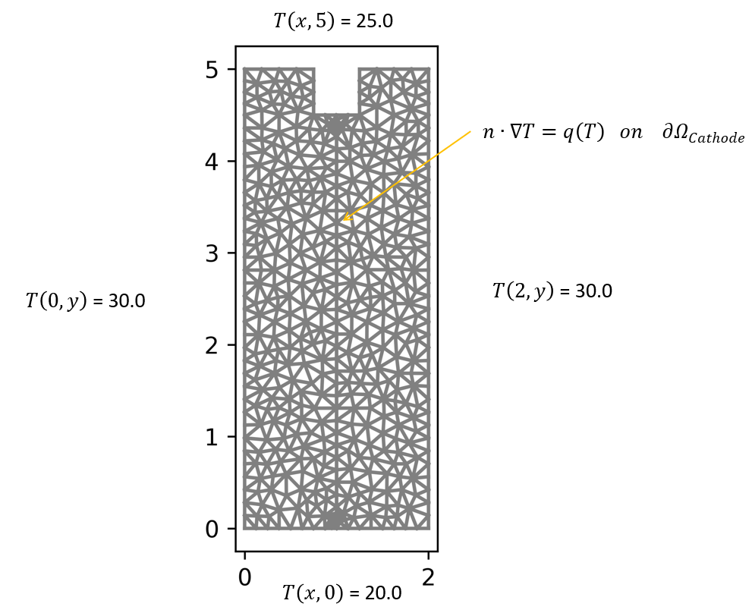

Figure . Battery domain marked with their respective Dirichlet and Neumann boundaries.

Results and Discussion

The total power lost to the surroundings of the battery over the simulation was about 54.10 Watts, where about 80% of the total power was lost from the left and right boundaries. Significantly less amounts of power were transferred through the top boundary, the tab domains, and the bottom boundary. Multiple frames of the heat distribution throughout the battery domain as well as a plot of the temperature across the battery can be seen below in Figures 2-4.

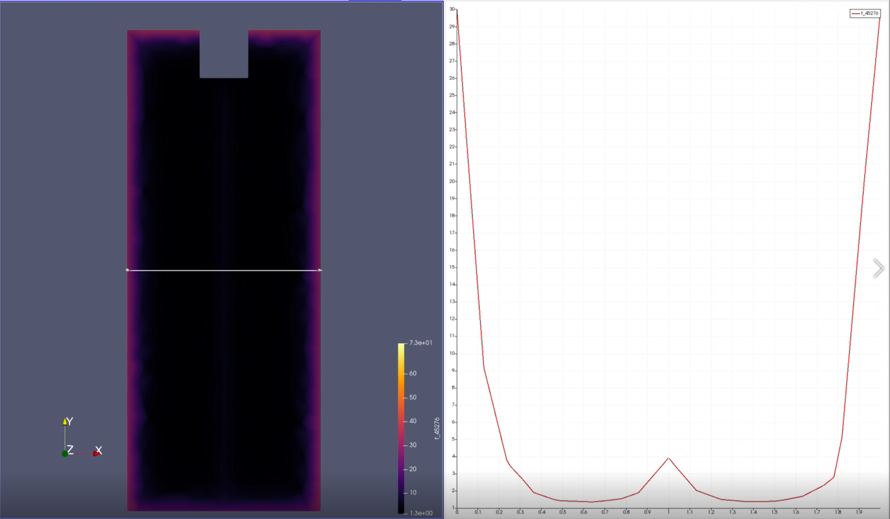

Figure 2. Paraview visualization of the heat distribution across the battery domain in degrees Celsius at t = 0.0 seconds.

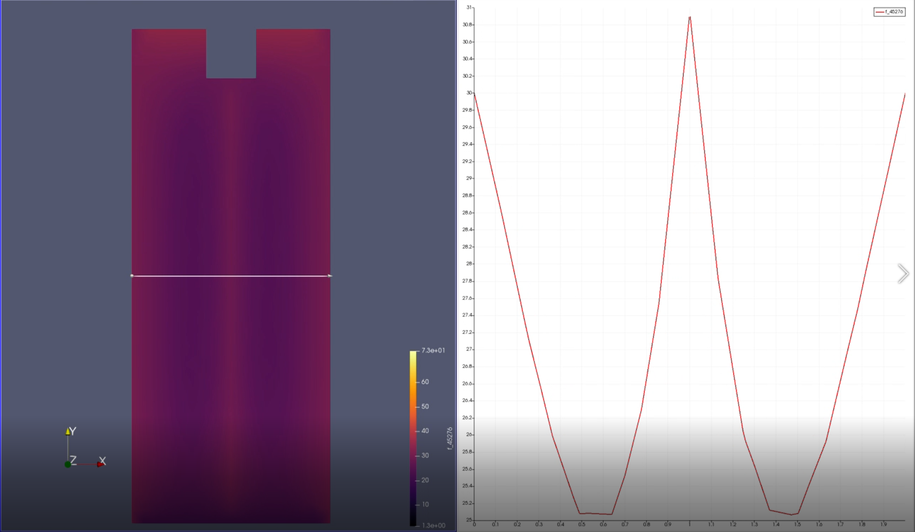

Figure 3. Heat distribution throughout the battery domain after 2 seconds of constant current discharge.

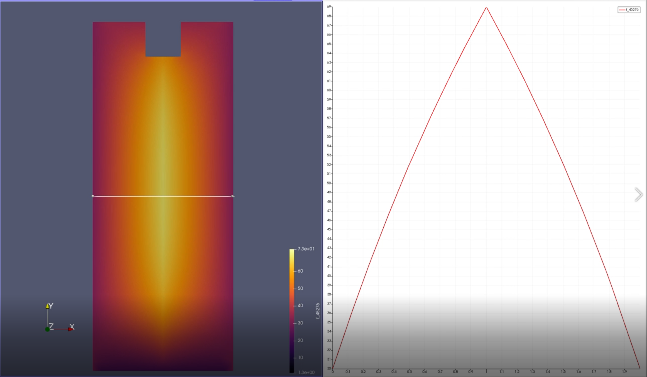

Figure 4. Battery simulation after 6 seconds of constant current discharge.

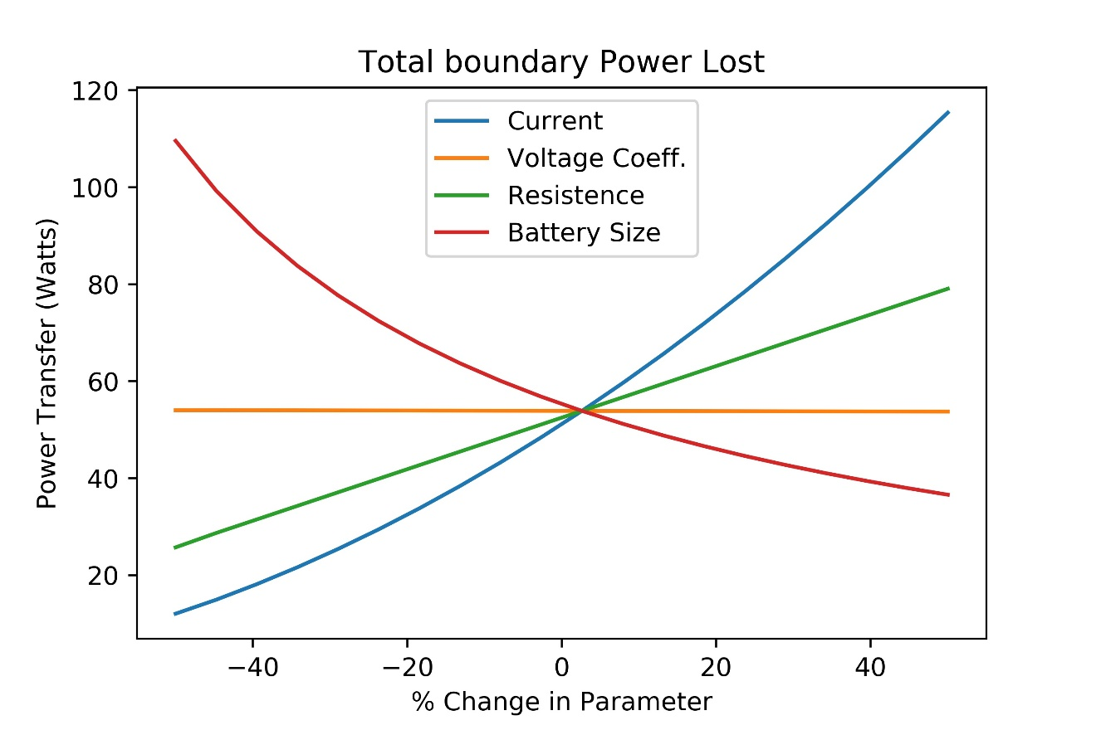

Figure 5. Investigating the uncertainty around the current, voltage coefficient, resistance, and battery size.

Conclusions

References

1. "Discharging at High and Low Temperatures." (2019). *Batteryuniversity.com*, <https://batteryuniversity.com/learn/article/discharging_at_high_and_low_temperatures> (Apr. 4, 2019).
2. Ahmadou Samba. 2015. Battery Electrical Vehicles-Analysis of Thermal Modelling and Thermal Management . Electric power*. LUSAC Université de caen Basse Normandie*; Vrije Universiteit Brussel, English.
3. Wang, Z., Ma, J., and Zhang, L. (2017). “Finite Element Thermal Model and Simulation for a Cylindrical Li-Ion Battery.” *IEEE Access*, 5, 15372–15379.

Appendix

